PSet 1

CS 7649 Robot Intelligence: Planning

Instructor: Matthew Gombolay

# Instructions:

* You may work with one or more classmates on this assignment. However, all work must be your own, original work (i.e., no copy + pasting code). You must list all people you worked with and sources you used on the document you submit for your homework
* **You must use Python version 3.6 to receive credit.**
* Zip all code and PDFs before submitting as a single, zipped folder.

# Problem 1:

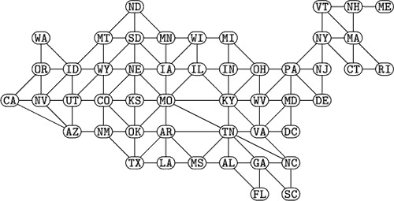Consider the following graph (credit Knuth 2008, p. 15):

Write six Python scripts implementing depth-first search (DFS), breadth-first search (BFS), and Iterative Deepening Search (IDS), each with and without a visited list. Use these algorithms to solve for a simple path from S 🡪 G, where S is Washington (WA) and G is Georgia (GA). Ties will be broken in alphabetical order. Augment your implementation to report the computational time, # of paths popped from the queue, maximum queue size, and length of returned path. You may manually define the graph in python or grab a definition from online. **Submit a PDF of this page having filled in these rows and columns:**

|  |  |  |  |  |  |
| --- | --- | --- | --- | --- | --- |
|  | **Visited List** | **Time (s)** | **# Paths Popped from Queue** | **Max Queue Size** | **Returned Path’s Length/Cost** |
| **DFS** | **No** |  |  |  |  |
| **Yes** |  |  |  |  |
| **BFS** | **No** |  |  |  |  |
| **Yes** |  |  |  |  |
| **IDS** | **No** |  |  |  |  |
| **Yes** |  |  |  |  |

You should have one Python file for each type of search, and the code should be clearly documented. Files should be named “[METHOD]_[VISITED].py” (e.g., “dfs_yes.py”). Further, when the grader runs the python code, the script should print to the screen the relevant information reported in the table above. **Remember, if it does not run, you do not receive credit.**